
PATUAKHALI SCIENCE AND TECHNOLOGY UNIVERSITY
COURSE CODE AIS-211

Assignment – 01
Virtual Organization

SUBMITTED TO:
Md. Tariqul Islam
Assistant professor
Department of Management Studies
Faculty of Business Administration

SUBMITTED BY:
Name: Md. Sharafat Karim
ID: 2102024,
Registration No: 10151
Faculty of Computer Science and Engineering

Date of submission: 24th April, 2024
Virtual Organization
A virtual organization is a type of organization where employees remotely connect with each other through distant networks.
Mainly these kinds of communications are performed using emails, video conferencing and other TCP/ IP protocols. In this way it enables even more interaction, dispersion and even more flexibility.
Here is a flow chart showing a virtual organization,
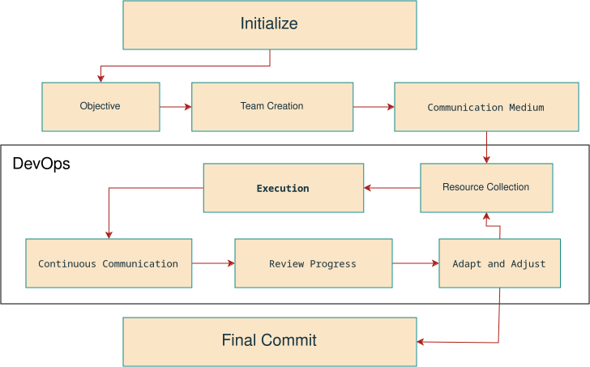
In this process,
- After initiating, a specific objective is defined.
- Communication channels are used for collaborating.
- Resources, other tools and technologies, are used for task execution.
- The virtual team carries out tasks with ongoing communication and collaboration to ensure project progression.
- Progress is periodically assessed, and adjustments are implemented as needed to keep the project aligned with its goals.
- At the same time the task is adjusted which again goes to phase allocating resources.
- The process continues until project completion, after which the virtual organization may mark their en or transition to new projects or objectives.

Characteristics
Some important characteristics are,
- Huge Variety: Members of a virtual organization may be located in different cities, countries, or even continents.
- Flexibility: Virtual organizations often offer flexible work arrangements, allowing employees to choose their hours and locations based on individual preferences and needs.
- Dependency: For the management of resources, a dependency management system is also required.
- Communication: It can come with some obstacles as virtually connecting is a bit different from connecting face to face.
- Diverse Skill Sets: Virtual organizations often bring together individuals with diverse skill sets and backgrounds, fostering creativity and innovation within teams.
- Digital Security: Virtual organizations must prioritize digital security measures to protect sensitive information and ensure data privacy for both employees and clients.
- Remote Leadership: Leadership in virtual organizations requires effective remote management skills, including the ability to motivate, communicate, and provide direction to team members who may be geographically dispersed.
Pros
Some advantages of using virtual organization are,
- Cost Savings: Virtual organizations often have lower overhead costs associated with maintaining physical office spaces, such as rent, utilities, and office supplies.
- Global Talent: Virtual organizations can tap into a global talent pool, allowing them to recruit the best candidates for specific roles regardless of geographic location. Which enables users from all over the world to participate.
- Flexibility: Virtual organizations offer greater flexibility in terms of work hours and locations, enabling employees to work from home or other remote locations, leading to improved work-life balance.
- Reduced Commuting: Employees in virtual organizations can avoid long commutes to and from the office, saving time and reducing stress associated with daily travel.
- Environmental Benefits: By reducing the need for employees to commute to a physical office, virtual organizations can help decrease carbon emissions and contribute to environmental sustainability.
Cons
Some disadvantages of using virtual organization are,
- Communication Challenges: Virtual organizations may face communication challenges due to reliance on digital communication tools, leading to misunderstandings, delays, and miscommunication among team members.
- Lack of Face-to-Face Interaction: The absence of face-to-face interaction in virtual organizations can hinder relationship-building, collaboration, and team cohesion, leading to feelings of isolation among employees.
- Digital Security Risks: Virtual organizations are vulnerable to digital security risks, such as data breaches, Cyber-attacks, and information stealing, requiring robust Cybersecurity measures to protect sensitive information.
- Difficulty in Managing Remote Teams: Managing remote teams in virtual organizations can be challenging, requiring effective leadership, communication, and coordination to ensure productivity and engagement among team members.
- Potential for Work-Life Imbalance: While virtual organizations offer flexibility, they may also blur the boundaries between work and personal life, leading to potential work-life imbalance and burnout among employees who struggle to disconnect from work.

Here are ten virtual organizations in Bangladesh,
- Neonbati (Blogging platform)
- Ubar (Ride sharing platform)
- Chaldal (E-commerce platform)
- Salebee (Software development company)
- Ajkerdeal (E-commerce platform)
- Banglalink (Telecommunication company)
- Robi (Telecommunication company)
- BrainyZat (Digital marketing agency)
- UX design bd (Online education platform)
- Techtunes Earn (Freelancing platform)

One of the most famous virtual organization,
One of the most famous virtual organization is Amazon Web Services (AWS). It is one of the world's largest cloud infrastructure that offers a wide range of cloud services, including Infrastructure as a Service (IaaS), Platform as a Service (PaaS), and Software as a Service (SaaS). AWS provides a comprehensive suite of cloud computing services, such as computing power, storage, databases, machine learning, analytics, and more.

